The Math is Finally Catching Up
Paul Lobosco 10/02/23

This is an important communication. I will be as brief as possible but I ask you all to read it. Please make an appointment with me using the link at the end.
All things considered, I continue to believe that it may be prudent to overweight bonds/cash and underweight stocks. I want you to understand why. I’ll make several points that relate to this matter of allocating our investments and then try to pull it all together.
- September, 2023. Markets were down quite a bit (we were not). The S&P lost ~5% for the month, mostly in the last 2 weeks. The 2023 highs in the S&P, notably, did not take out the 2021 highs. The last 30 days:
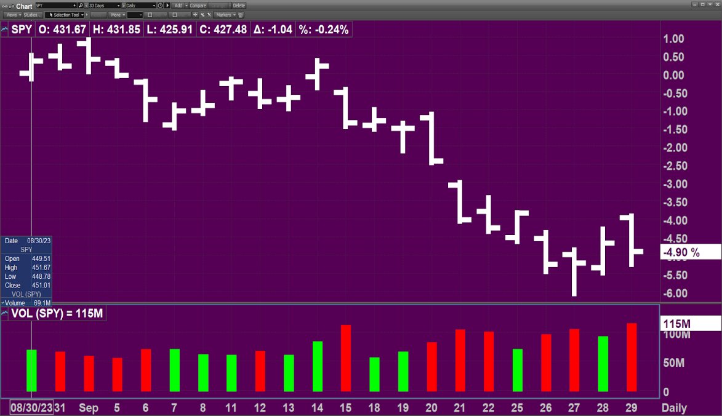Market-Q

As was the case in the first part of 2022, markets have begun to experience a very bumpy ride. The potential good news is that with interest rates so high, Bonds are offering better returns than at any time in the last 16 years! But we have to be careful. Short-term (< 10 years) and high-quality bonds should be the focus. Rates are still rising. I’m hearing predictions of a 6% 10-year Treasury. If that turns out to be true, then it is too early to lock in longer-term rates.
- Below the surface in stocks: Here is a year-to-date chart of RSP, an ETF that invests in an “equal-weighted S&P”. It is actually down in 2023:
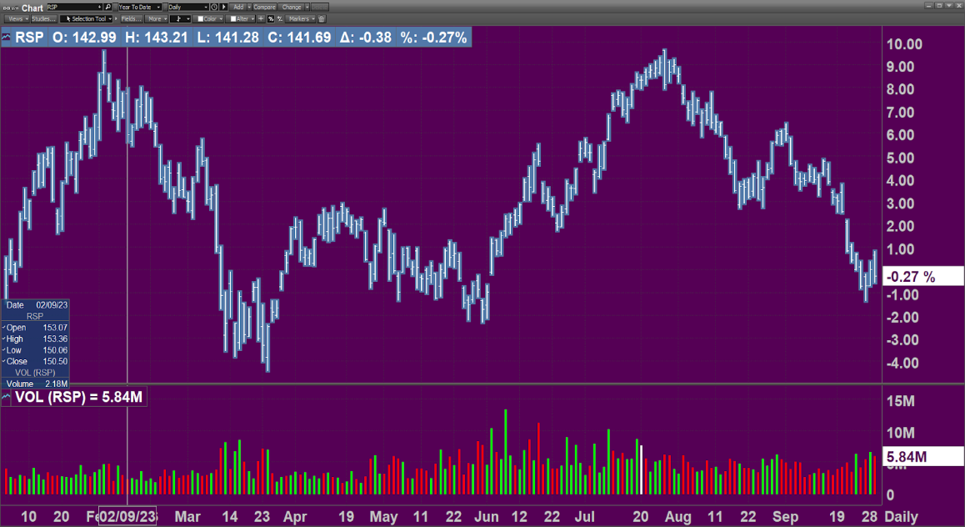 Market-Q

So clearly, there are just a handful of names propping up markets. This is a result of passive ETF investing and post-capitalist form of Oligopoly. Compared to bonds, stocks are doing poorly overall. The stock market is exhibiting a type of Darwinism we never anticipated. This is NOT a healthy backdrop for stocks, and leaves even the largest names quite vulnerable.

- Equity risk premium. As shown by this chart below, the ERP is at its lowest level in a very long time. Actually, today it is almost Zero. What this means is that investors may anticipate little or no additional return from equities relative to bonds. Generally, the chart suggests it is simply not worth the risk to be in stocks based on this measure alone. Of course, in the short term this is not always the best indicator, as we learned in the late 1990s. But then came 2001. Remember? The timing is tricky, but math wins in the end:
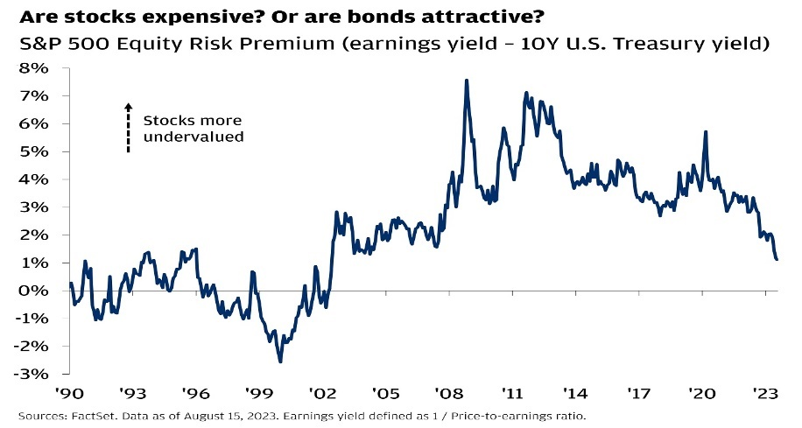

- The consumer represents more than 2/3 of the overall economy as measured by GDP. This is very concerning, because most consumers are largely tapped out. More than half of all Americans cannot get their hands on $1,000 in an emergency. Sixty percent of Americans are living paycheck-to-paycheck! 60%!! Many have had to resort to credit cards with 20%+ interest. Student loan payments are resuming after a multi-year suspension. Mortgage payments are off the rails and will keep a lid on future spending. A majority of retailers are being hit hard by lower sales and lower margins. Though I won't go into this here, much of our reported GDP is actually a credit-driven mirage. In real terms, it needs to come down. So, we have an increasing numerator and, at best, a stagnating denominator. Bad combination. This is the legacy of our so-called capitalist system. It is not hard to see how a stock like Target (shown below) loses nearly 60% in the last 2 years. (note- this is not a prediction about TGT stock- there are countless names like it):

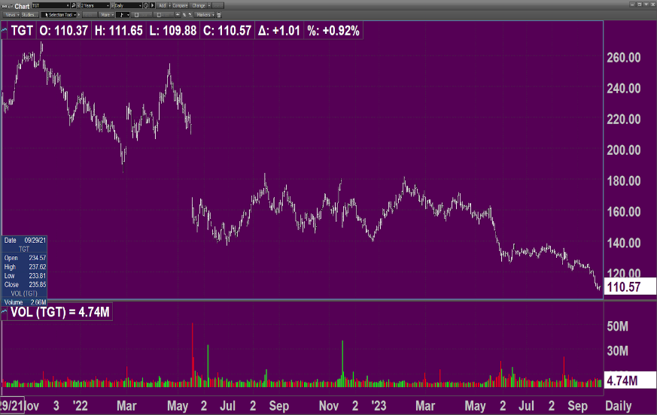 Market-Q

Here is a chart showing the rise in delinquencies:
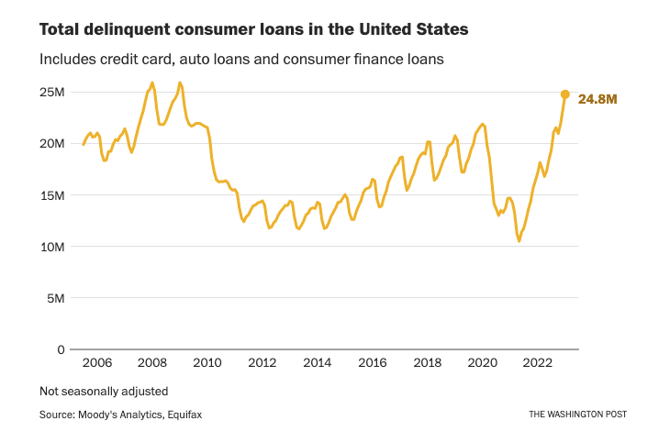

- Recession all but certain? The Inverted yield curve has been flashing ‘recession’ for over a year now. Many say a recession is already unfolding in staggered fashion. We have gotten to a point where fiscal and monetary policy, for political reasons, are designed to avoid a recession as much as possible. However, recessions are part of the natural seasonal cycle of an economy. They are necessary. But they are politically inconvenient. The longer our elected (and unelected) officials try to stave off recession, the worse it may be. Here is the Bond yield curve at the end of 2021, less than two years ago. And next to it is the yield curve today. Yes, short-term rates have gone from near zero to over 5%. That is unprecedented in terms of both speed and magnitude. Even long-term rates have risen substantially, just not by as much. A sea change! (source: U.S. Treasury)

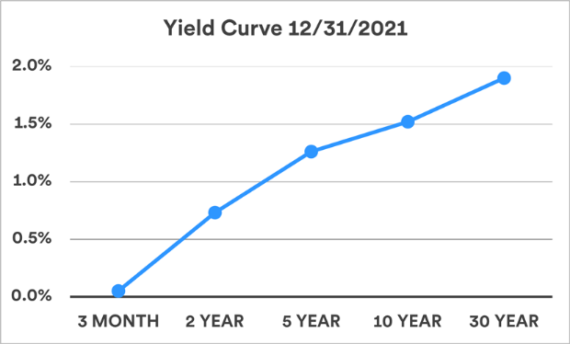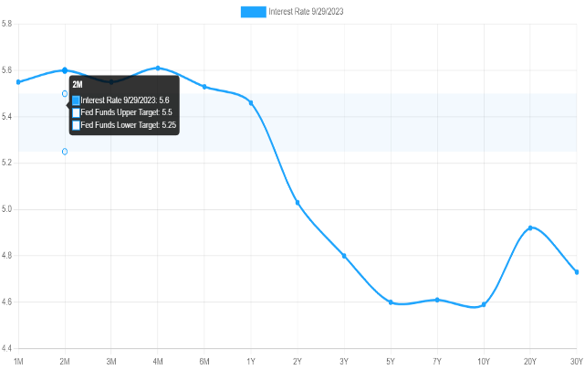

- Our Debt-to-GDP Ratio: Economists like to refer to debt-to-GDP as a measure of how healthy our economy is. Here’s the problem: Debt is rising at an increased level and our federal debt is now over $33 trillion. The interest costs alone are debilitating, accounting for well over $1 trillion annually. The interest cost is only set to increase. That is simply money that we are giving away to the holders of our debt. Yes, Debt is the Devil’s Playground. This chart shows a 50-year history of Debt-to-GDP:
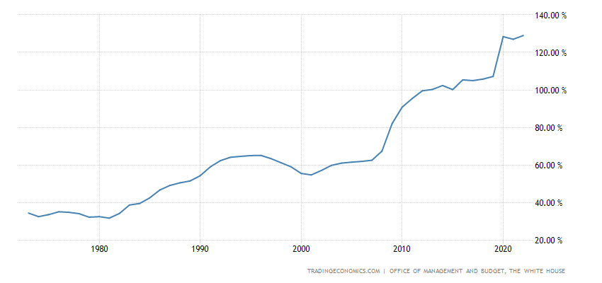
- Morphine-Dependency. As I have written many times, our economy has relied on an increasing amount of credit issuance, ever since we went off the gold standard in 1971. The repeal of Glass-Steagall in the 1990s, and the continual backstop offered by the Federal Reserve, have ushered in an obscene amount of credit issuance. It’s all funny money. We have privatized the gains to the top and socialized losses upon taxpayers. This has led to an historic and quite grotesque wealth gap. We are becoming an outright feudal society. My communication last month about real estate trends underscores this scary trend. It costs someone more than twice as much to buy a home today as it did just 3 years ago. Delinquencies are, as you would guess, on the rise.
- The Walking Dead. There are an astounding number of ”zombie” companies trading in the market, including many in the S&P 500. This chart below gives you an indication. Zombie companies are those whose balance sheet cannot survive over time. Their debt burdens will increase as they need to refinance at higher rates, but their cash flows and earnings are not enough to offset that. As a result many of them may file for bankruptcy. Many already have, but it doesn’t get reported much. Sometimes these companies receive a lifeline in the form of asset-backed Lending, but for the most part they are The Walking Dead. 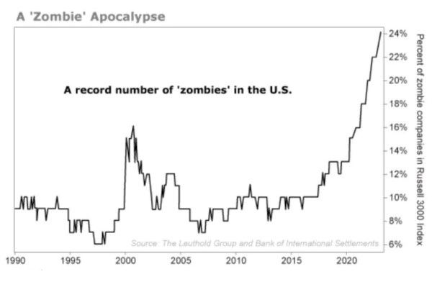
- The technicals in the market are extremely troubling, at least to me. There are just a handful of names that are propping up the market, The Lion's Share of companies are in significant downtrends. The number of stocks that are gapping down is increasing. Small and mid-cap companies, in particular, are prone to shocking one-day drops. And when it happens, they usually do not bounce back. This is how air comes out of the bubble.

- Having been at this a while, I remember several key years in the market. This year, 2023, reminds me a lot of 1987. No one knows what October will bring this year, but the tape action so far is eerily similar to what preceded October 29, 1987. I do not think we would have a single day decline like that again, due to circuit breakers, but the same result can occur over a period of weeks or months. That is not my base case, but the odds of a larger decline are increasing. Banking, Technology and Healthcare- all three of those sectors are dangerous and should be avoided in my view, unless there is a very specific reason for owning them or if they come down substantially in price. They all have major challenges ahead. Many banks cannot survive higher rates. The Financial ETF, XLF, is shown here, as its price has fallen below both its 50- and 200-day moving average:

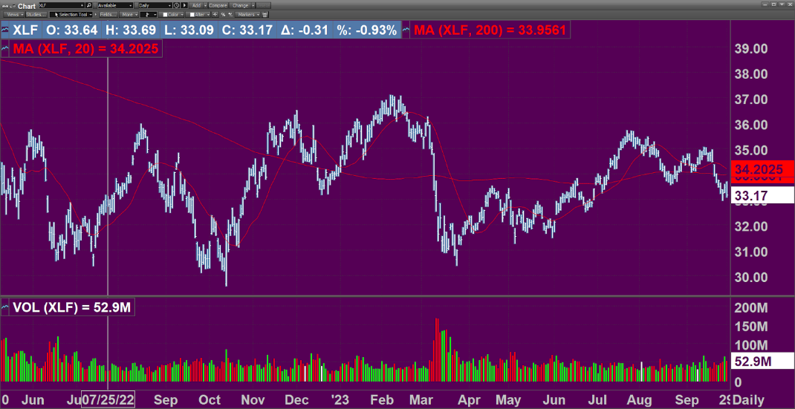 Market-Q

Healthcare represents 18% of our GDP, yet we are one of the sickest nations on earth. So something is very wrong, and it is not unreasonable to ask questions about motive in this industry. Is the Healthcare business model based on wellness or sickness? What would happen to our GDP if we all suddenly got healthy?

Technology is about to face a huge backlash from turning citizens/customers into cattle. The Surveillance State is going to be met with harsh criticism and likely policy changes. As I heard a prominent figure state recently: Capitalism is only good if it is harnessed to a social purpose. Through financialization, we have strayed very far from the capitalist ideal most of us have come to know.

- Geopolitical challenges. We all know that the 2024 election is around the corner. The Ukraine war is taking a serious toll on many levels. Some say a war with China is brewing. Markets are going to discount the civil unrest and disharmony well before next November. In fact they have already begun to. Markets can do well in the face of these events, though that is unlikely if they result in loss of Democracy. Authoritarianism or Tyranny can come from either side and result in an Orwellian future. I invite you to join me in recognizing that concept.

(cont’d)

The items highlighted above represent but a partial list of the many challenges we face as investors. In the end, I believe the casualty will be the U.S. Dollar, but perhaps only after many other fiat currencies fail first. That can take years, even decades. As I often say, we have turned Bedford Falls into Pottersville. This means credit has served as a substitute for genuine capital. Most of us treat Assets as Equity without considering the Liabilities that Mr. Potter has imposed upon us. That’s because those liabilities are not shown to you. But they are very real. And they are taking the form of Inflation, Bankruptcies, Feudalism, and ultimately Lower Asset prices. It is a gigantic confiscation scheme, the greatest bait and switch in human history. This is certainly the last thing I would wish to communicate, but I have to keep it real with you.

At Forward Capital, we are very experienced in dealing with bear markets. There are very specific strategies we apply. I am not predicting a bear market. I am saying that the probabilities for one are high. There are ALWAYS both bearish and bullish things one can point to. Being as objective as I can be, it appears the preponderance of bearish signals are dominant today.

Finally, here is my calendar. With many times available through early November.
I really look forward to connecting with you.

www.calendly.com/FCM-Lobosco

ARTICLES:
https://www.cnbc.com/2023/08/31/living-paycheck-to-paycheck-inflation-is-still-squeezing-budgets.html

https://www.forbes.com/sites/johntobey/2023/09/30/stock-market-selloff-is-confirmed/

https://www.axios.com/2023/08/15/credit-loan-delinquency-2023-above-pre-pandemic-levels

The opinions stated are that of the author and not that of The Investment Center, Inc. All Securities Offered Through The Investment Center, Inc. Bedminster, NJ Member FINRA/SIPC. Advisory Services Provided Through IC Advisory Services, Inc. - A Registered Investment Advisor. Paul Lobosco is a registered representative of The Investment Center, Inc. – Forward Capital Management, LLC is not affiliated with the Investment Center, Inc.. Paul Lobosco is not a research analyst and the information contained herein does not constitute a research report.
The information contained is derived from sources believed to be accurate. However we do not guarantee its accuracy. The information contained is for general use and it is not intended to cover all aspects of a particular matter. Neither the information presented nor any opinion expressed constitutes a representation by us or a solicitation of the purchase or sale of any securities. The information contained is not appropriate, by itself, to guide investment decisions. This material does not constitute a personal recommendation or take into account the particular investment objectives, financial situations, or needs of individual recipients. Strategies, financial instruments, or securities mentioned herein may not be suitable for all investors.
The Investment Center, Inc. does not forecast future economic environments and cannot comment on how it might do in any future economic scenario. There may be economic times where all investments are unfavorable and depreciate in value. The Investment Center, Inc. makes no predictions, representations, or warranties herein as to future performance. Future performance is difficult to predict and such predictions are beyond the control of The Investment Center, Inc. Current performance may be lower or higher than the performance data quoted. Past performance is not a guarantee of future results. Although all investments may be adversely affected by currency fluctuations or global economic, political or social instability, investments issued by entities based outside the United States, particularly in countries with developing economies and/ or markets, may be affected to a greater extent
This email transmission and its attachments are the property of The Investment Center, Inc. and are intended solely for the use of the individual or entity to which this email is addressed. Distribution, retention, printing, or other use of the email, attachments, or copyrighted material is expressly prohibited. If you are not the named addressee, or this email has been sent to you in error, please immediately notify the sender by reply email and permanently delete the email and its attachments.

